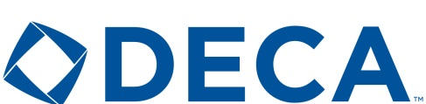 Minot High School 1100 11the Ave. SW Minot, ND 58701
Gifts in Kind Donation Form
We would love to have you speak to our classes, be a member of our advisory board, assist with our charitable events, or other nonmonetary items or services. Please describe your donation below

Business Name
Individual’s Name:
Address
City: State Zip Code: Phone:
Web Site Recognition Preference:
Businesses that sponsor students and/or the Minot High DECA chapter may elect to be recognized on our website found at http://www.marketingmps.com/sponsors.html.
No, while I am donating, I do not want to be recognized on your website
Yes I would like to be added to your web site
If yes, we will add the Business name, the individual’s name, or both in recognition for your sponsorship. See our examples below and enter exactly how you would like this added to our page.
Examples: James Johnson, XYZ Construction
James Johnson
XYZ Construction
I would like recognition shown as follows:

^{signature} ^{date}

